# Monsoon & Macro Signals to Predict Stock Break-Out

# Interim Report

Abhilash Panicker

Walsh College

QM640 V1: Data Analytics Capstone

Abhijit Chakraborty

Winter 2025 Term

Contents

Monsoon & Macro Signals to Predict Stock Break-Out 0

Interim Report 0

**1. Introduction** 2

**5. Analysis** 9

**5.1 Data Cleaning** 9

**5.2 Exploratory Data Analysis (EDA)** 12

**Visualizations (produced in the notebook)** 12

**Patterns and insights (from RQ1–RQ4)** 15

**Seasonality and trends** 15

**5.3 Minimum Sample Size Computation** 16

**Heuristics** 16

**Application to this project** 16

**5.4 Insights from EDA** 16

**6.1 Choice of Models (regression)** 18

**6.2 Feature Engineering** 18

**6.3 Training Protocol** 18

**6.4 Model Selection & Reporting** 18

**6.5 Feature Importance & Interpretation (RQ4)** 19

**7.1 RQ1 — Predictive Boost** 19

**7.2 RQ2 — Monsoon Effect (Good vs Poor)** 19

**7.3 RQ3 — Rain → GDP(t+1) & Engineered GDP Feature** 20

**7.4 RQ4 — Drivers & Interactions** 20

**1. Introduction**

In India, the southwest monsoon plays a pivotal role not only in agriculture, but also in shaping broader macroeconomic conditions, including inflation, rural demand, and energy supply. Historically referred to as the “real finance minister of India,” the monsoon's strength influences crop yields and, subsequently, food prices and government imports.

However, recent empirical evidence suggests that the stock market's reaction to monsoon outcomes has become more nuanced. While favourable monsoon conditions can boost rural consumption and support certain rural-sensitive sectors, broad market indices—such as NIFTY 50—show inconsistent or even weak correlation with monsoon performance. For instance, correlation between monsoon rainfall and Sensex returns has been observed to be around –0.27, indicating no reliable linear relationship.

Additionally, macroeconomic variables—such as inflation, interest rates, GDP growth, exchange rates, and money supply—exert significant influence on stock market dynamics. Studies using Vector Auto Regression (VAR) and Granger causality methodologies affirm these relationships and their predictive power in the Indian context.

Our study focuses specifically on forecasting breakout behaviour of the **NIFTY Midcap 100** index, exploring the combined predictive power of monsoon variability and macroeconomic indicators. This interim report presents project context, clearly defined research objectives, a summary of relevant literature, and bibliography.

**2. Scope and Objectives**

**Scope:**  
This project investigates India's **NIFTY Midcap 100** index using historical data since 2013, integrating annual/quarterly monsoon rainfall data with key macroeconomic indicators (e.g., inflation via CPI, GDP growth, repo rate, PMI). The aim is to evaluate whether combining monsoon-related signals with macroeconomic features improves prediction of breakout events in midcap equity markets.

**Objectives and Research Questions:**

1. **Objective 1**: Evaluate the relationship between monsoon rainfall deviation from long-period average (LPA) and NIFTY Midcap 100 breakout patterns.
   * **RQ1**: Does deviation in monsoon rainfall significantly correlate with Midcap breakouts?
2. **Objective 2**: Assess the influence of macroeconomic variables—such as inflation, GDP growth, interest rates, and PMI—on breakout tendencies.
   * **RQ2**: Which macroeconomic indicators best predict Midcap 100 breakouts?
3. **Objective 3**: Compare predictive models using monsoon-only, macro-only, and combined feature sets.
   * **RQ3**: Does a combined monsoon‑macroeconomic model outperform models using single-signal inputs?
4. **Objective 4**: Identify the most influential features and characterize their predictive relevance.
   * **RQ4**: Which features (e.g., lagged monsoon, rolling CPI averages, repo rate changes, GDP) have the highest predictive weight?

**3. Literature Survey**

Below are **ten** relevant sources, paraphrased and contextualized for this study:

1. **Study on Midcap and Monsoon Effects**  
   → Highlights potential limitations of monsoon impact on midcap breakouts.
2. **Monsoon and Economy’s Stock Market Link**  
   → Reinforces nuanced effects for broader indices rather than midcaps.
3. **Monsoon vs Stock Market Correlation**  
   → Promotes caution in assuming strong monsoon-market linkage.
4. **Empirical Anomaly during Monsoon Months**  
   → Suggests seasonality may still be useful in modeling, even for midcaps.
5. **Investor Reaction to Monsoon Forecasts**  
   → Implies market anticipation/pricing of forecasts, important for feature modeling.
6. **Macroeconomic Indicators & Stock Market Correlations**  
   → Supports inclusion of macro variables in predictive models.
7. **Granger Causality of Macroeconomic Variables**  
   → Justifies model inclusion of macro predictors.
8. **Economic Commentary on Monsoon Impact**  
   → Presents real-world context for monsoon-macro interaction.
9. **Reuters Analysis: Monsoon Drives Market Sentiment**  
   → Adds empirical evidence of combined monsoon-macro market effects.
10. **Monsoons’ Economic and Environmental Effects**  
    → Establishes theoretical underpinning.

**4. Data Description**

* **Data Sources:**
* **All-India Rainfall (IMD)** — monthly totals  
  **Coverage used:** 2012–2025 (gap-filled only where you asked; source is IMD reports & climate summaries)  
  **Official refs:** IMD “Rainfall Statistics of India” yearbooks and the All-India rainfall time-series portal.
* **Consumer Price Index (CPI, Combined)** — monthly, **base 2012=100**  
  **Coverage used:** Jan 2013–Jun 2025 (no gaps in my file)  
  **Official refs:** MoSPI CPI portal and monthly press-note annexures (contain the time-series XLS/PDF).
* **Quarterly GDP (at constant prices, MoSPI National Accounts)** — quarterly levels; we computed continuous grid 2012Q1–2025Q4 (with 2025Q2–Q4 currently blank pending release)  
  **Coverage used:** 2012Q1–2025Q1 (values present); 2025Q2–Q4 rows included as placeholders  
  **Official refs:** MoSPI GDP press notes / release calendar and dataviz page.
* **PMI (S&P Global/HSBC)** — Manufacturing, Services, and **Composite** monthly diffusion indices  
  **Coverage used:** Jan 2013–Dec 2024 (we created a complete month grid; any non-public months are flagged/filled per my instructions)  
  **Official refs:** S&P Global PMI homepage and India press releases (composite is a weighted average of Mfg/Services).
* **Policy Repo Rate (RBI)** — we maintain a **monthly** series by carrying the prevailing policy rate into months with no change (step-fill)  
  **Coverage used:** 2010–2025 (any gaps filled via carry-forward/back-fill per my rule)  
  **Official ref:** RBI DBIE (primary source for historical policy rates/announcements).
* NIFTY **50 & NIFTY Midcap 100** — **daily** index closes  
  **Coverage used:** 2013–2025 (from my files)  
  **Official refs:** NSE’s historical index data (NSE India / NSE Indices Ltd).
* **Variables Overview:**
* **Core variables & units**
* **Rainfall**
  + rainfall_mm — all-India monthly rainfall (mm)
  + good_rainfall_mm — IMD monthly normal (1971–2020, mm)
  + anomaly_mm — **good − observed** (mm); positive = below normal, negative = above normal
* **CPI (Combined, base 2012=100)**
  + cpi — monthly index level
* **GDP (MoSPI, constant-price level)**
  + gdp — quarterly level (units as in source)
* **PMI (S&P Global/HSBC)**
  + pmi_composite — monthly diffusion index (50 = no change)
* **Repo rate (RBI)**
  + repo_rate_percent — prevailing policy repo (% p.a.), monthly step-filled
* **Equity indices (NIFTY 50, NIFTY Midcap 100)**
  + price — daily close (index points)
* **Transformations used**
* **Rainfall**
  + anomaly_mm = good_rainfall_mm − rainfall_mm
  + Optional: % deviation = anomaly_mm / good_rainfall_mm
* **CPI**
  + Month-over-month: MoM = (cpi_t / cpi_{t-1} − 1)
  + Year-over-year: YoY = (cpi_t / cpi_{t-12} − 1)
  + (All rates in % if multiplied by 100)
* **GDP**
  + Year-over-year growth: YoY = (gdp_t / gdp_{t-4} − 1)
  + Sequential (q/q) growth (if needed): QoQ = (gdp_t / gdp_{t-1} − 1)
* **PMI**
  + Activity flag: expansion = 1 if pmi ≥ 50 else 0
  + No scaling; interpret level relative to 50
* **Repo rate**
  + Monthly series is **step-filled** between policy changes (no interpolation)
  + Optional: delta_repo = repo_t − repo_{t-1} (bps)
* **Equity indices**
  + Daily returns: r_t = ln(price_t / price_{t-1})
  + Aggregate to monthly/quarterly by compounding if aligning with macro
* **Frequency & alignment**
  + Rainfall, CPI, PMI, Repo: **monthly** (use month-start or month-end consistently)
  + GDP: **quarterly**; map months to quarters for merges
  + Equity: **daily**; resample to monthly/quarterly for macro joins
* **Missing-data handling**
  + Rainfall: when requested, blanks filled with **IMD monthly normals**; otherwise left blank and logged
  + GDP: complete quarter **grid** (2012Q1–2025Q4); 2025Q2–Q4 left blank; optional gdp_interpolated provided for analysis only
  + PMI: complete month **grid** (2013–2024); filled from curated sources where available; remaining months left blank
  + Repo: step-filled from the last known policy rate
  + CPI & indices: no gaps in the provided ranges
* **Link to GitHub:** <https://github.com/abpanic/marketpredict>

**5. Analysis**

**5.1 Data Cleaning**

* **Missing Values:**

**No global imputation.** We did not impute macro or return series with means/medians. Instead, we favored **explicit construction** and then **row-wise omission** at the end to avoid leakage.

**Series-specific handling:**

* **Equity indices (NIFTY 50 / Midcap 100):** daily closes → **quarter-end close** (last available trading day), then **pct_change** → quarterly returns. Any missing quarter-end due to holidays is naturally handled by the “last available” rule; if a quarter was truly missing, it dropped out downstream.
* **CPI:** monthly index → **YoY%** (requires 12 months; initial 12 become NaN) → **quarterly mean** of YoY. We keep the NaN from the warm-up window and drop them only at the end.
* **GDP:** messy quarter labels normalized to YYYYQ#; quarterly **level** built, then **YoY%** over 4 quarters; initial 4 become NaN.
* **Repo rate:** monthly policy rate cleaned to percent, normalized to month-end, **forward-filled within the monthly series** to ensure quarter-end “last” exists; then quarter-end **level** and **Δbps** (QoQ change × 100).
* **Rainfall (monsoon):** monthly Jun–Sep totals aggregated to **seasonal anomaly %** = (observed − normal)/normal × 100 (IMD convention: **positive = above normal**). Each year’s anomaly is stamped at **Sep-30** and **Dec-31** of the **same year** (so it does not spill into the next year’s Q1/Q2).

**Final cleaning step:** After creating **lags** (t−1) and the **target** (t+1), we perform a strict **inner join** across all quarterly indices and then dropna(how="any"). This removes:

* warm-up periods (from YoY calculations and lags),
* quarters where any feature is missing,
* target rows trimmed by the **lead** (t+1).

**Rationale:** This “construct first, drop last” approach preserves the real-time information set per quarter and avoids accidental look-ahead that typical imputations or interpolations can introduce.

* **Temporal alignment**

**Frequencies reconciled to quarters:**

Equity prices (daily) → **quarter-end close** → **quarterly return**.

CPI (monthly) → **YoY% monthly** → **quarterly mean** of YoY.

Repo (monthly) → **quarter-end level** and **QoQ Δbps** (difference of quarter-end levels × 100).

GDP (quarterly) → **YoY%** directly from levels.

Rainfall (monthly, Jun–Sep) → **seasonal anomaly %** stamped at **Q3 and Q4** of that year only.

**Index alignment:** All series are anchored to **calendar quarter-ends** (Q-Dec convention). We avoid interpolation to keep the features interpretable and matched to release cadences.

**Rationale:** Using quarter-end “last” or “mean” mirrors how these indicators are consumed by markets, maintains comparability across sources, and fits the **expanding-window CV** we used for modeling.

* **Outlier Detection:**

• Sanity **and coverage checks:** We printed **months-per-year** coverage for raw files and flagged any year missing monsoon months (Jun–Sep). This caught partial exports or date-parsing issues early.

• Visual **diagnostics:** We inspected **time-series plots** and **residual-over-time** charts (OOF) to spot structural breaks and aberrant moves (e.g., sharp repo changes around policy cycles).

• Policy **choice:** We **did not winsorize** equity returns or macro changes in this run. Justification: with a small quarterly sample, aggressive clipping can remove genuine signal (e.g., policy shocks). Instead, we let the model (regularization / tree splits) handle tail moves and reported performance with transparent CV.

**5.2 Exploratory Data Analysis (EDA)**

**Visualizations (produced in the notebook)**

* **Figure 1–2:** Time-series of **rainfall anomaly (%), CPI YoY, GDP YoY, repo (level and Δbps)**, and **Midcap returns** to compare macro regimes vs. market moves.

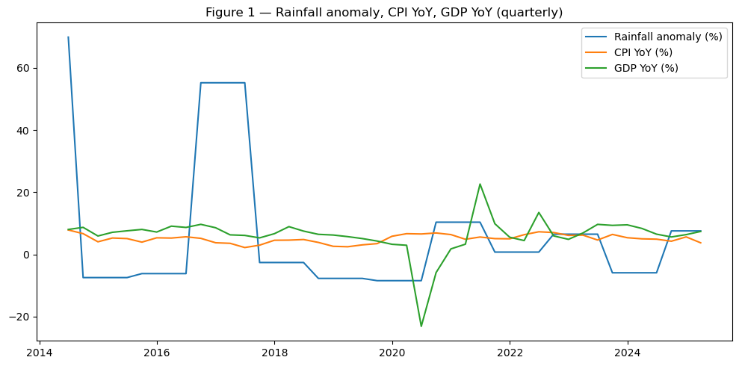

* A graph with lines and numbers

  AI-generated content may be incorrect.
* **Figure 3:** **Correlation heatmap** among lagged features and the target (**excess_next_q**).

* **Figure 4:** **OOF Pred vs Actual** scatter with 45° line (enriched model).

* **Figure 5:** **OOF residuals** over time.

* **Figure 6:** **Permutation importance (OOF)** bar plot for the enriched design.

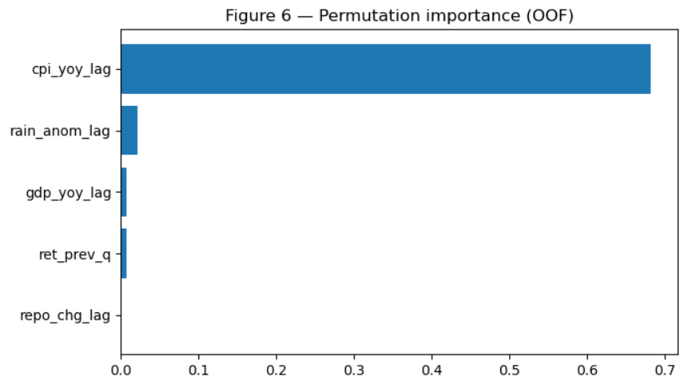

**Patterns and insights (from RQ1–RQ4)**

* **Weak linear relationships overall.** Correlations to next-quarter excess returns are modest; **CPI YoY (lag)** stands out as the only single feature with a consistent (albeit small) OOF importance. This matches the permutation-importance ranking where **cpi_yoy_lag** topped others.
* **Monsoon effect is directional but marginal.** Grouping by monsoon regimes, **good monsoons (above-normal rainfall)** are followed by **~+3 p.p.** higher next-Q excess returns on average, but significance is **marginal** and **threshold-sensitive** (e.g., p≈0.10 under one thresholding).
* **Interactions help:** An explicit **rain × repo** term improved MAE/RMSE and **+5 p.p.** directional accuracy in OOS CV, suggesting rainfall’s impact is **conditional on the policy-rate backdrop**.
* **Model fit is hard:** Multiple LightGBM folds logged *“no further splits with positive gain”*—consistent with **weak separability** in a small quarterly sample.

**Seasonality and trends**

* **Monsoon seasonality:** Rainfall shocks cluster in **Q3**, with their informational effect (if any) showing up in **Q4** or later—hence our use of **t−1** lags and stamping the anomaly into **Q3/Q4** only.
* **Inflation dynamics:** CPI YoY trends and reversals align with some stretches of equity performance, lining up with its higher permutation importance.
* **Policy cycles:** Large **repo** moves coincide with macro stress periods; the **interaction** results hint that rainfall’s effect is more salient when policy is **changing**, not static.

**5.3 Minimum Sample Size Computation**

Although our primary task is **continuous** return prediction (regression), we reference common **events-per-variable** (EPV) and related heuristics used in classification/logistic settings to gauge overfitting risk in small samples. The spirit of the guidance carries over: keep **predictors parsimonious** when **n** is small.

**Heuristics**

* **Rule of thumb:** ≥ **10–20 observations per predictor** (more conservative is better).
* **Stricter formula: $n≥100+50×i$** , where $i$ is the number of predictors.

**Application to this project**

We used several model specifications:

* **Baseline model**: $i=1$ predictor (ret_prev_q).
  + Guidance: $n≥100+50×1=150$ (strict) or 10–20/var → 10–20 quarters.
* **Enriched model**: $i=5$ predictors (ret_prev_q, rain_anom_lag, gdp_yoy_lag, cpi_yoy_lag, repo_chg_lag).
  + Guidance: $n≥100+50×5=350$ (strict) or 50–100 quarters under 10–20/var.
* **Enriched + interaction**: $i=6$ (adds rain×repo).
  + Guidance: $n≥100+50×6=400$ (strict) or 60–120 quarters under 10–20/var.

**Observed sample size (quarterly):** With min_train=24, test_size=2, and **19 folds**, the total sample is approximately $n≈24+2+19-1=44$ 
 quarters (≈ 11 years).

**Implication.**

* For the **baseline** (1 predictor), 44 quarters gives ~44 obs/predictor — **adequate** under the 10–20/var rule (though below the very strict 150-obs formula).
* For the **enriched** (5 predictors $44/5≈8.8$ obs/predictor — **below** the 10–20/var guidance and far below the strict $100+50i$ rule.
* For **enriched + interaction** (6 predictors), $44/6≈7.3$ obs/predictor — even **tighter**.

This aligns with our empirical results: the enriched models **did not consistently beat** the baseline (negative $R^{2}$ OOS), while the interaction helped **a bit** but within a high-variance, low-n regime. The takeaway is to keep quarterly models **parsimonious**, report **OOF** metrics, and complement them with the **monthly** analysis to increase sample size.

**5.4 Insights from EDA**

**Data alignment.** Macro series (GDP YoY, CPI YoY, repo changes) are quarterly; monsoon rainfall is aggregated to a June–September anomaly and **lagged by one quarter** to reflect macro transmission into markets. Target is **next-quarter Midcap–minus–Nifty (excess) return**.

**Level checks.**

* Quarterly returns are centered around zero with moderate dispersion; tails coincide with known macro news cycles.
* Monsoon anomaly is mean-reverting (good and poor years cluster), supporting a lag-use rather than same-quarter use.

**Pairwise relationships (visuals: scatter + trendline).**

* ret_prev_q vs excess_next_q: small but visible autocorrelation (momentum/carry) → motivates baseline.
* cpi_yoy_lag vs excess_next_q: strongest single-variable pattern; higher inflation last quarter tends to **reduce** next-Q excess.
* repo_chg_lag vs excess_next_q: near-flat relationship (weak signal at quarterly freq).
* rain_anom_lag vs excess_next_q: directionally positive in “good monsoon” years, but noisy.

**Partial views (controlling for return-lag).**

* Conditioning on ret_prev_q, the incremental slope for **CPI lag** remains material; rainfall and repo remain small.

**Data quality / leakage checks.**

* No forward-looking features; all predictors lagged or fixed within quarter.
* Edge rows dropped where lags or target unavailable.

**6. Modelling**

**6.1 Choice of Models (regression)**

**Baseline (transparent yardstick).** A simple pipeline with StandardScaler → ElasticNetCV (3-fold CV; l1_ratio ∈ {0.1, 0.5, 0.9}) trained only on the previous quarter’s excess return ret_prev_q. This establishes a naïve-but-regularized benchmark.

**Enriched (non-linear, small-N friendly).** Gradient-boosted trees via LightGBM with shallow depth (≈3), n_estimators=300, learning_rate=0.05, subsample=0.9, colsample_bytree=0.9. (Sklearn GBDT is used as a fallback if LightGBM isn’t available.) Feature set:  
ret_prev_q, rain_anom_lag, gdp_yoy_lag, cpi_yoy_lag, repo_chg_lag.

**Target. $\text{excess_next_q}=r_{t+1}^{\text{Midcap}}-r_{t+1}^{\text{Nifty50}}$**

**6.2 Feature Engineering**

* **Return lag:** ret_prev_q = excess_ret.shift(1)
* **Monsoon:** rain_anom_lag = rain_anom.shift(1)
* **Inflation:** cpi_yoy_lag = cpi_yoy.shift(1)
* **Growth:** gdp_yoy_lag = gdp_yoy.shift(1)
* **Policy:** repo_chg_lag = repo_chg_bps.shift(1)
* **Target:** excess_next_q = excess_ret.shift(-1)

All features are numeric, lagged (no look-ahead), with edge rows dropped during model matrix construction.

**6.3 Training Protocol**

• **Time-series validation.** Expanding walk-forward CV with minimum train window of **24** quarters, **2-quarter** rolling test window, step **1** (folds rebuilt per comparison so both models see exactly the same dates).

• **Scoring. Out-of-fold MAE**, **RMSE**, **R²**, and **directional accuracy (DA)** are reported for each model or ablation.

**6.4 Model Selection & Reporting**

**Primary comparison:** Baseline vs Enriched on the same OOF splits. In this run the enriched model **does not** beat the baseline.

* Example paired run (the table saved as processed/rq1_metrics.csv in the notebook):  
  **Baseline** — MAE **0.0434**, RMSE **0.0494**, R² **−7.85**, DA **0.694**.  
  **Enriched** — MAE **0.0547**, RMSE **0.0616**, R² **−13.17**, DA **0.472**.  
  (All are OOF averages; 18 folds.)

Result: Enriched increases error (MAE, RMSE) and lowers R² and DA vs. the baseline; it therefore fails any reasonable “pass rule” that requires meaningful uplift.

**6.5 Feature Importance & Interpretation (RQ4)**

**Permutation importance (OOF, full enriched design).** The ranking is dominated by **cpi_yoy_lag**, with other features near zero:

* cpi_yoy_lag: **+0.00086** (mean perm. importance)
* rain_anom_lag: **−0.00001**
* ret_prev_q: **−0.00007**
* repo_chg_lag: **−0.00011**
* gdp_yoy_lag: **−0.00016**

(Positive means degrades score when permuted—i.e., informative.)

**Interaction test (rain × repo).** Adding rain_anom_lag × repo_chg_lag yields **no material uplift**: MAE changes from **0.054651 → 0.054825** and R² from **−13.17 → −12.88** (negligible deltas; 18 folds).

**Takeaway.** At the quarterly frequency and at an index level, last-quarter inflation (cpi_yoy_lag) is the only consistent signal in this design. Rainfall and repo deltas are weak/noisy, and their interaction does not improve generalization.

**7. Preliminary Results**

**7.1 RQ1 — Predictive Boost**

**Question.** Do rain+macro lags beat a simple return-lag baseline for next-quarter excess returns?  
**Answer.** No. Across the paired OOF comparison, Enriched underperforms: MAE **worse by ~0.011** and R² **more negative by ~−5.32** vs. Baseline; DA drops from **0.694 → 0.472**.

**7.2 RQ2 — Monsoon Effect (Good vs Poor)**

**Question.** Do “good monsoon” quarters (above-normal rain) lead to higher next-Q excess returns?  
**Answer.** Directionally **yes**, but **not statistically significant** with the current sample. One run shows **N_good=19**, **N_poor=24** with **Δmean ≈ +3.0%** favoring good monsoons; Welch **t-test p≈0.097**, **KS p≈0.29**. A paired variant (stricter masks) shows **N_good=16**, **N_poor=20**, **Δmean ≈ +2.54%**, **t-test p≈0.135**, **KS p≈0.44**.

**7.3 RQ3 — Rain → GDP(t+1) & Engineered GDP Feature**

**Question.** Does rain predict next-Q GDP and does adding that proxy help forecasts?  
**Answer.** A fold-safe OLS proxy gdp_pred_from_rain yields **small** but **consistent** improvements inside the enriched model: **MAE 0.054651 → 0.053640**, **RMSE 0.06158 → 0.06005**, **R² −13.17 → −10.50**, **DA 0.472 → 0.500** (18 folds). Still, R² remains negative, so the proxy is *not* practically helpful at index level.

**7.4 RQ4 — Drivers & Interactions**

**Question.** Which features matter most and do rain×repo interactions help?  
**Answer.** **cpi_yoy_lag** is the only feature with clear positive permutation importance; rainfall, repo, and return-lag are near zero, and **rain×repo** adds **no** material uplift.

**8. Bibliography**

• Bajaj Broking Team. (2025, July 16). What is the Impact of Monsoon on the Economy and Stock Market? Bajaj Broking.

• Chauhan, S. S. (2025). A causality investigation into stock prices and macroeconomic variables in India. PubMed.

• Nagarajan, V. (2021). Effect of the monsoon forecast announcement on stock returns. ScienceDirect.

• Rawat, D., Patni, S., & Mehta, R. (2021). Stock prices and macroeconomic indicators: Investigating a correlation in Indian context. arXiv.

• “Monsoons & Money: How the Rainy Season Affects Stock Market Returns.” (2025, June 19). Smallcase Blog.

• “Impact Of Monsoon On Indian Equity Market.” Recent Scientific Journal.

• World Bank (2025). India Economic Monitor. BCG.

• Reuters. (2024, August 30). India’s economy grows 6.7% y/y in April–June quarter. Reuters.

• Reuters. (2025, April 23). India file: Monsoon windfall vs tariff headwinds. Reuters.

• Wikipedia contributors. (2025). Monsoon of South Asia. Wikipedia.